Connecting to Cummins’ Network Remotely Via VPN:
- Connect to your home or remote location’s Internet.

- On your Desktop, open “Cisco AnyConnect Secure Mobility Client”.
  - OPTIONAL: If desktop Cisco icon is not there, then press the Windows key () on your keyboard and begin typing “Cisco”.
    - Open “Cisco AnyConnect Secure Mobility Client”.
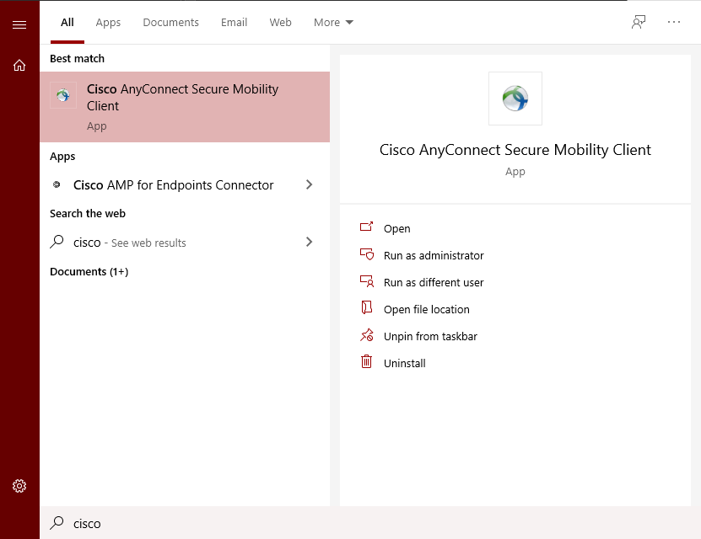

- You should see “US Remote Access” selected. Click “Connect”.
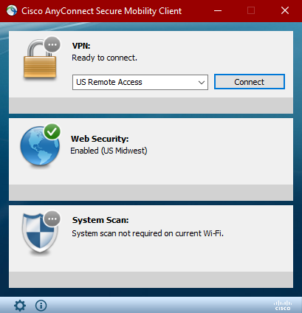

- Login with your Cummins credentials (username = WWID). Click “Accept” when prompted.
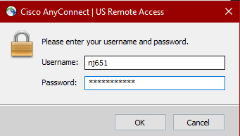

- Please wait as the system connects to VPN. This could take 1-2 minutes.
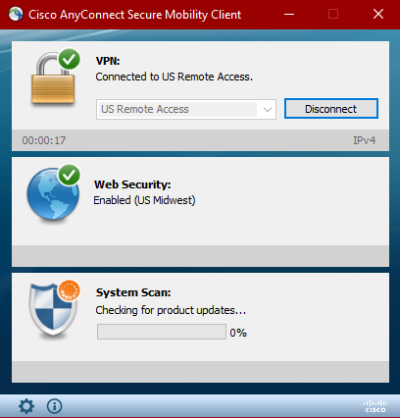

- You should now be able to access Cummins’ internal applications, including those SEP specific ones. If you do not see the three green check marks as shown below or have any issues please reach out to Adam K Johnson/nj651. Note VPN is not required for Skype meetings or Outlook emails.
