1. | Go to https://cummins.leavelogic.com  Click Sign up and complete the registration information using Company Code: Cummins if you do not have a company specific address. You will receive an email to confirm your registration. | 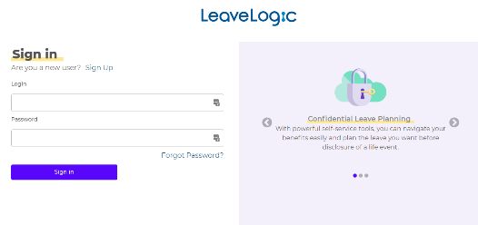
2. | You will see a landing page which gives you information about LeaveLogic and what to expect as you plan for your leave.  Click Start planning your leave.  You will be asked a series of brief questions about your situation which LeaveLogic will use to design a custom draft LeavePlan.  If you are planning an intermittent leave, you should talk with your manager as situations and benefits eligibility may vary. You will have the ability to model your intermittent leave in LeaveLogic and request assistance through in app chat, if helpful. | 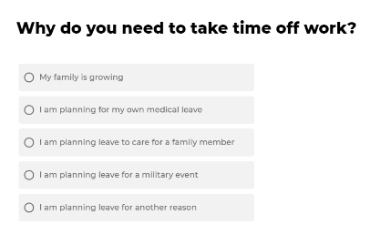  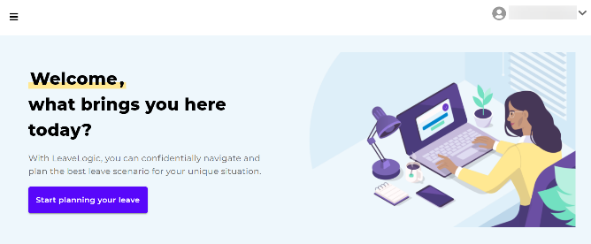
3. | After you create your LeavePlan, a guided tour will help you understand how to navigate LeaveLogic:  - Timeline. Review Paid and Job Protected leave by date.  - To-Do’s. Review all Required and Recommended actions.  - Benefits. Learn more about related benefit and leave options.  - Profile. Update preferred email and notification preferences. | 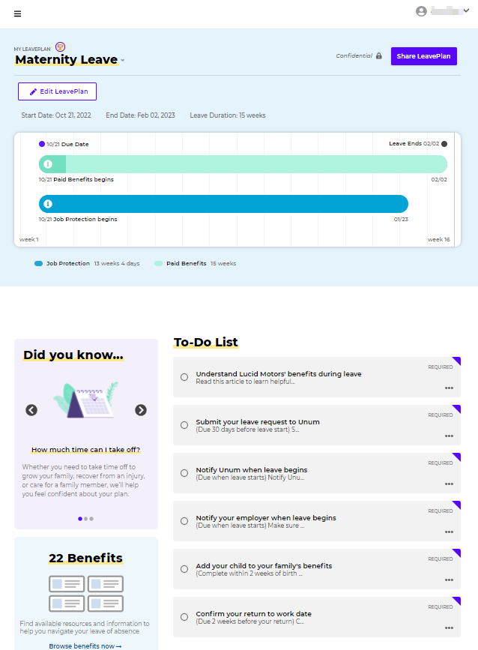

4. | Your Timeline displays various Key Dates and how paid and job protected leave benefits coordinate to provide for time off during leave.  Customize your LeavePlan by clicking Edit LeavePlan. Once in edit mode, you may click on calendar dates or Change Key Dates to modify your plan. | 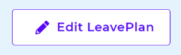  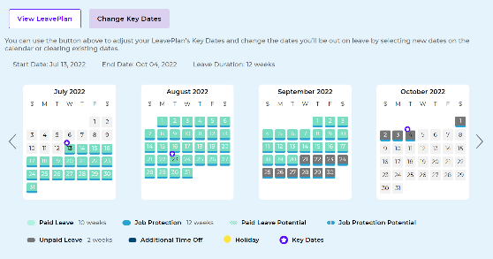
5. | Your To-Do’s offer a list of actions to complete to take leave. Required tasks are highlighted on your home screen but you may click on the To-Do List header or from the Menu on the left to see all Required and Recommended tasks.  Required actions will often have guidance on when you must complete the task. Recommended tasks will help you better understand your leave and make suggestions for things you may not think about. | 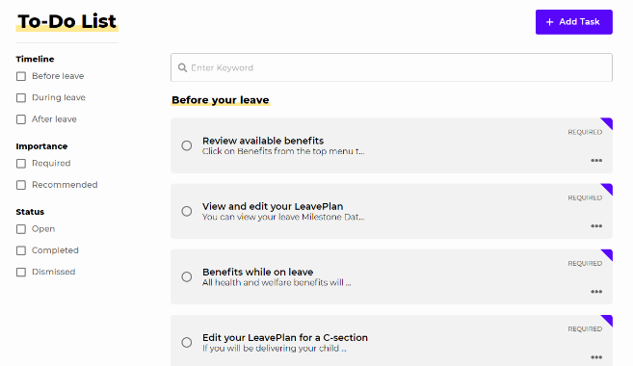
6. | Benefits offer a one-stop module for viewing and understanding the various standard and voluntary benefit programs available to you associated with your leave.  You may access your benefits from the Benefits tile on the Home page or on the Menu to the top left of the screen. | 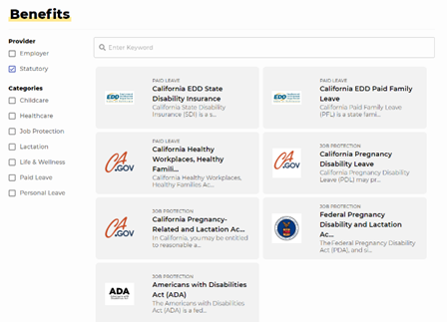
7. | Profile settings can be accessed by clicking the down arrow next to your name at the top right to change language preferences, user information, notification preferences, and other profile details.  Note: Add a personal email to receive To-Do reminders while on leave. | 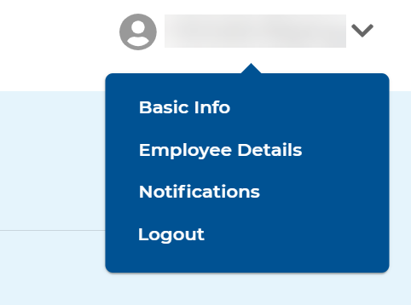

8. | You can create multiple LeavePlans at the same time, if needed, by clicking on the Create a new LeavePlan link in the menu on the far left. | 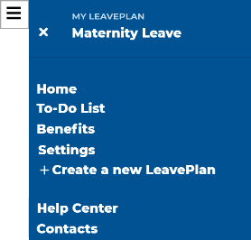
9. | For any active LeavePlan, you can change the name, archive or download a .pdf by clicking the down arrow next to the name of the LeavePlan on the Home screen. | 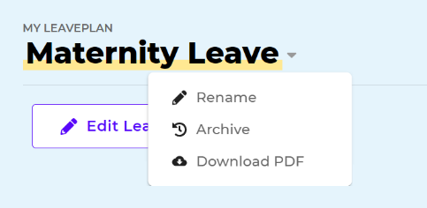
10. | To initiate your leave, you must notify your manager and submit your leave request to Unum as outlined in your LeavePlan tasks.  Note: LeaveLogic does not share your draft LeavePlan with your manager, your leave administrator, or your employer. If there is a change to your leave dates you should notify your manager and your leave administrator.
11. | 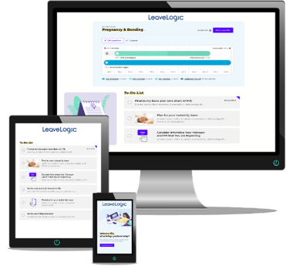  Additional Information and Support  Visit EmpoweringYou.Cummins.com  Questions about Benefits?  Contact cbsbenefits@cummins.com  Technical Questions about LeaveLogic?  Contact LeaveLogic at support@leavelogic.com
DISCLAIMER: This material is presented to you for informational purposes only. It has been designed to help you better understand your benefits. Because this is only a brief overview it cannot address all the provisions that may apply to you. This guide provides a summary of benefits available to eligible employees. If the summary information in this guide differs from a provision contained in any employer policy, benefit plan document or contract, the policy, benefit plan document or contract controls. Employer reserves the right to unilaterally, at any time and in its discretion, amend, supplement, modify, or eliminate any or all of the benefits described in this guide or elsewhere. This guide does not create a contract or guarantee of employment between the employer and any individuals.

Your confidential LeaveLogic account and the resources within LeaveLogic are available for you to use at your own discretion, and do not constitute required nor mandatory steps for obtaining a Leave of Absence (LOA). Access and use of LeaveLogic is intended for planning purposes only.

